**Assignment - 4**

|  |  |
| --- | --- |
| Assignment Date | 22 October 2022 |
| Student Name | Kishore R |
| Team ID | PNT2022TMID43416 |
| Project Name | Smart Waste Management System For Metropolitan Cities |
| Maximum Marks | 2 Marks |

**Question:**

Write code and connections in wokwi for ultrasonic sensor. Whenever distance is less than 100cms send “alert” to ibm cloud and display in device recent events

**PROGRAM:**

const int TRIG_PIN = 7;

const int ECHO_PIN = 8;

// Anything over 400 cm (23200 us pulse) is "out of range"

const unsigned int max_dist = 23200;

void setup() {

  // The Trigger pin will tell the sensor to range find

  pinMode(TRIG_PIN, OUTPUT);

  digitalWrite(TRIG_PIN, LOW);

  //Set Echo pin as input to measure the time duration of pulse returning back from the distance sensor

  pinMode(ECHO_PIN, INPUT);

  // We'll use the serial monitor to view the sensor output

**Serial**.begin(9600);

}

void loop() {

  unsigned long t1;

  unsigned long t2;

  unsigned long pulse_width;

  float cm;

  float inches;

  // Hold the trigger pin high for at least 10 us

  digitalWrite(TRIG_PIN, HIGH);

  delayMicroseconds(10);

  digitalWrite(TRIG_PIN, LOW);

  // Wait for pulse on echo pin

  while ( digitalRead(ECHO_PIN) == 0 );

  // Measure how long the echo pin was held high (pulse width)

  // Note: the micros() counter will overflow after ~70 min

  t1 = micros();

  while ( digitalRead(ECHO_PIN) == 1);

  t2 = micros();

  pulse_width = t2 - t1;

  // Calculate distance in centimeters and inches. The constants

  // are found in the datasheet, and calculated from the assumed speed

  //of sound in air at sea level (~340 m/s).

  cm = pulse_width / 58.0;

  inches = pulse_width / 148.0;

  // Print out results

  if ( pulse_width > max_dist ) {

**Serial**.println("Out of range");

  } else {

**Serial**.println("*******************************");

**Serial**.print("Distance Measured in cm : ");

**Serial**.println(cm);

    if(cm<100){

      // while(true){

**Serial**.println("Alert !!");

      // }

    }

**Serial**.print("*******************************");

  }

  // Wait at least 1000ms before next measurement

  delay(1000);

}

OUTPUT:

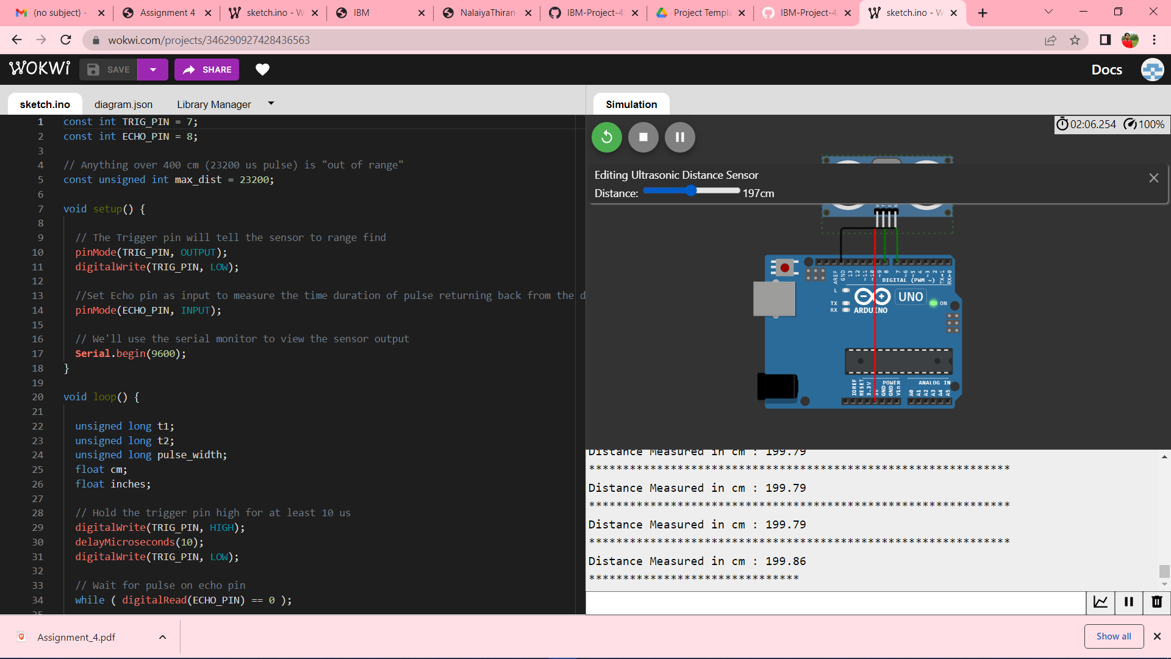

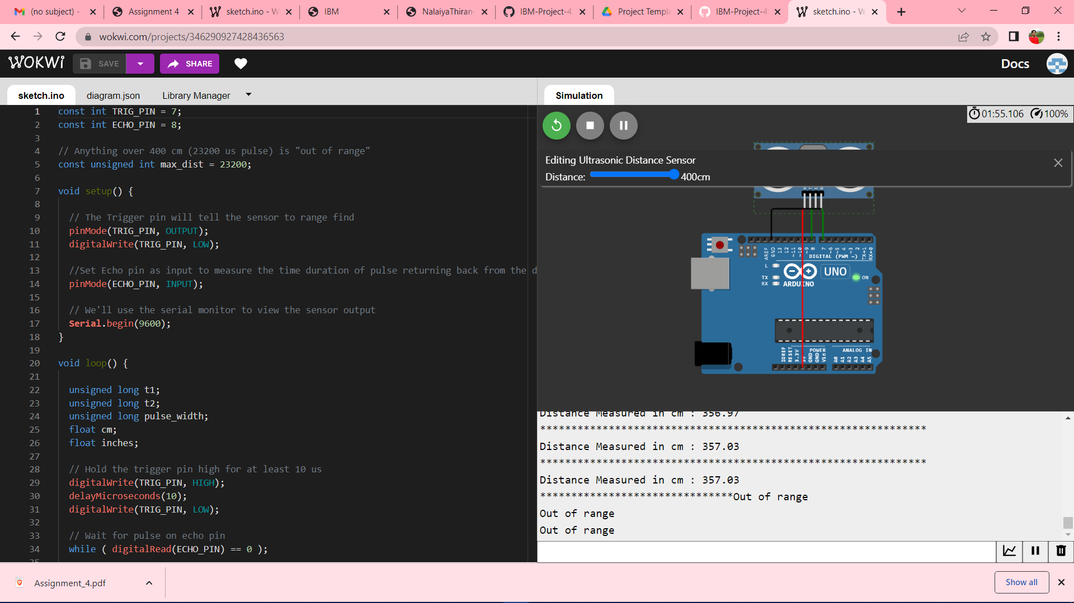

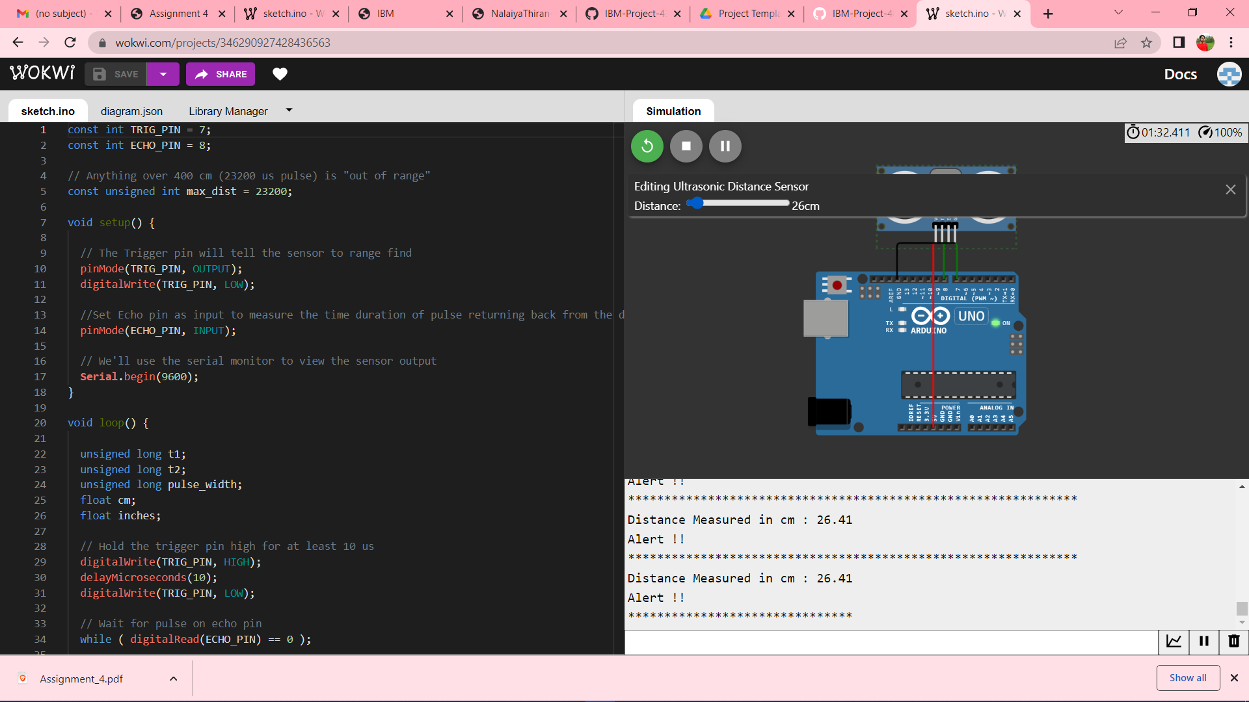

**Project Link:** <https://wokwi.com/projects/346290927428436563>